SIDAA Championship Round Distances



Canadian 1200 Round

|  |  |  |
| --- | --- | --- |
| **Age Group** | **Round** | **Distances** |
| **Seniors** | Canadian 1200 | 70m, 60m, 50m, 40m |
| **Masters, Juniors U20, U17 and Crossbows** | Short Canadian 1200 | 60m, 50m, 40m, 30m |
| **Juniors U14 and U12** | Junior Canadian 1200 | 50m, 40m, 30m, 20m |

720 Rounds

**72 arrows-10 zone scoring**

|  |  |  |  |  |
| --- | --- | --- | --- | --- |
| **Gear** | **Recurve** | | **Compound** | |
| **Age group** | **Distance** | **Face size** | **Distance** | **Face size** |
| **65+ Men** | 60m | 122cm | 50m | 80cm |
| **65 + Women** | 60m | 122cm | 50m | 80cm |
| **50-64 Men** | 70m | 122cm | 50m | 80cm |
| **50-64 Women** | 60m | 122cm | 50m | 80cm |
| **Senior Men** | 70m | 122cm | 50m | 80cm |
| **Senior Women** | 70m | 122cm | 50m | 80cm |
| **Junior Men** | 70m | 122cm | 50m | 80cm |
| **Junior Women** | 70m | 122cm | 50m | 80cm |
| **Cadet Men** | 60m | 122cm | 50m | 80cm |
| **Cadet Women** | 60m | 122cm | 40m | 80cm |
| **Intermediate** | 45m | 122cm | 45m | 80cm |
| **Cub** | 35m | 122cm | 35m | Full 80cm |
| **Kiwi** | 25m | 122cm | 25m | Full 80cm |

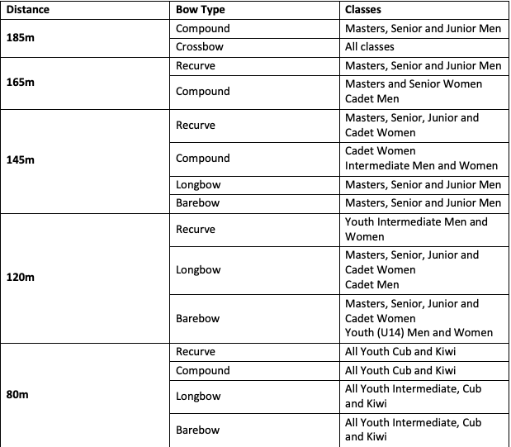Clout Round

